
PUBLIC TALK
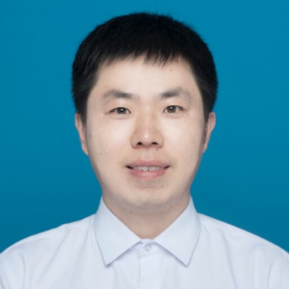
Talk Abstract
Metasurfaces are 2D artificial materials made of subwavelength elementary cells that give rise to unexpected wave properties that do not exist naturally. By rationally configuring the shape, size, position, and orientation of unit cells with high spatial resolution, one can manipulate the phase, amplitude and polarization of light and thus engineer its wavefront at will. Optical fibre tips that combine fibre optics and planar technologies are emerging as one of the most promising light-coupling platforms for nanophotonic devices. Integrating plasmonic metasurfaces on optical fibre tips to form metafibers expands the functionalities of an ordinary optical fibre to nanoscale manipulation of light, yielding a variety of advanced applications such as planar waveshaping, super-resolution imaging, and ultracompact sensing. This talk will first give a brief review on metafiber devices that the talker explored in his past 5 years and then focus on the metafiber electro-optic modulator to show a detailed example.
Plasmonic Metafiber Devices
About the speaker
Jiyong Wang is a professor in Hangzhou Dianzi University, China. He received his double PhD degrees in Physical and Theoretical Chemistry from Eberhard Karls University of Tuebingen, Germany, and in Nanoscience and Technology from the University of Technology of Troyes, France in 2017. He then joined the near-field optics group at the CNRS-University of Bourgogne as a post doctoral researcher for one year. From 2018 to 2022, he worked as a research assistant professor at Westlake University, China. Since then, he started his research at Hangzhou Dianzi University as a full-time professor. His research interests include nanophotonics, optical engineering and their cross discipline applications in ocean science and engineering. He published more than 20 paper in the highly-impacted academic journals, including Light: Science & Applications, Optica, PhotoniX, Light Advanced Manufacturing, Nanoscale et al.
24th November 2023, Friday 4.00pm-5:00PM A3-824

Feifang.chung@xmu.edu.my │ Department of Physics │ Xiamen University Malaysia

